Practical - 6
Practical Title: Rendering External JSON Data using Fetch API, Search and Filter
Display event lists, student profiles, notices, or FAQs from external JSON
files using Fetch API. Implement dynamic rendering, search, filter,
sorting, and pagination.

Theory
1. How is JSON fetched, parsed, and rendered?
The external JSON file is fetched asynchronously using fetch('../data/student.json'), parsed into a JavaScript object via await response.json(), and rendered onto the web page by looping through the data array and assigning formatted strings to .innerHTML.
2. Which array methods are used for search, filter, sort, and pagination?
A standard for loop is currently used to iterate and display the course items. Search, filtering, sorting, and pagination can be implemented using standard array methods such as .filter(), .sort(), .slice(), and .indexOf() / .includes().
3. How are loading and error states handled?
Loading states are handled by displaying initial placeholder text ("Loading student details..." and "Loading courses...") directly inside the HTML elements until the fetched data overwrites them. Error states can be managed by wrapping the fetch() call inside a try...catch block to handle network or file resolution failures gracefully.
4. How is modularity maintained in JavaScript files?
Modularity is maintained by separating function responsibilities within js/script.js, such as keeping validateRegistration() for form handling and loadCoursePageData() for dynamic JSON fetching, allowing functions to be independently called by their respective HTML pages.

Output
- Created an external student.json file to store student profile information and enrolled course lists separately from the HTML structure.
- Implemented an asynchronous JavaScript function using fetch() and await response.json() to load and parse the external JSON data dynamically on page load.
- Handled the loading state with placeholder text and dynamically injected student details and courses into the web page DOM using .innerHTML and array iteration.
To View Code: https://github.com/shreyajodhani/studenthub.git

Evidence of Work (Screenshots)
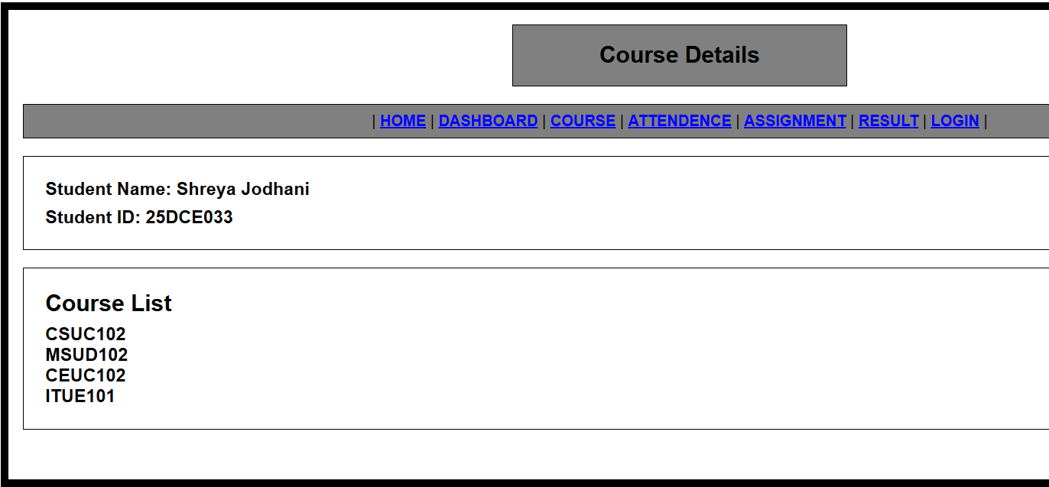
Description:
Course page with all the details fetched from student.json file.

GitHub Repository Link: https://github.com/shreyajodhani/studenthub.git

Challenges Faced:

Data was not being fetched properly

Learning Outcomes:
Learnt to fetch data from files
Faculty Remarks: (Keep this blank for faculty)

